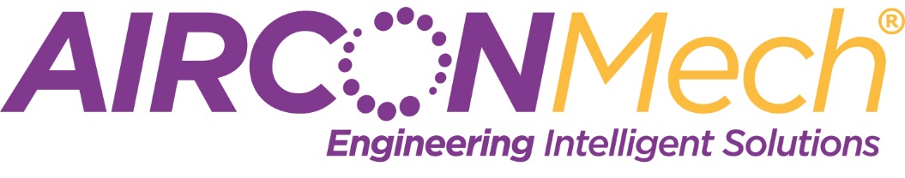

We Are Hiring!

The Senior Project EHS Advisor will be leading all aspects of the day-to-day EHS function from administration to on the ground safety compliance and will report into the site Project Manager and the Company EHS Director. This role involves working with the client safety manager on EHS compliance. This is a mechanical services project specific role based in Dublin with approximately 20-25 staff involved in the package and with the potential for further roles post completion.

For you:
- Very competitive salary (negotiable)
- Laptop
- Phone
- Project specific role with the potential for further opportunities within the business
- CPD Development Programme
- Experience working on one of the most prestigious projects in Ireland

Responsibilities:
- Management of EHS E-filing system
- Champion problem solving /continuous improvement
- Support the project managers on all aspects of EHS
- Prepare and communicate RAMS
- Introduce innovation and drive safety initiatives on site
- Manage all incident investigations as required and report in accordance with the company/project standards, enabling the investigation of accidents and compilation of accident data; to co-operate with staff responsible for insurance and other related matters
- Carry out and close out EHS audits
- Work closely with the client and manage all issues proactively
- Coordinate inductions and ensure the training matrix is maintained
- Deliver TBTs

Requirements:
- Proven 4 years minimum EHS construction Management experience
- Degree or Diploma in Occupational Health and Safety
- Excellent communication skills both written and verbal
- Proficient user of MS office
- Excellent report writing skills
- Be meticulous in attention to documentation
- Work well within a team

Job Types: Full-time, Permanent Schedule: Monday to Friday

Competitive package offered commensurate with experience.

AirconMech is an equal opportunities employer

